 ­ ­­­­

Detroit Red Wings v. Winnipeg Jets

**Thursday, December 12th, 2019 | 7:30 p.m.**

Join us in honoring Law Enforcement, Firefighters, EMTs and all First Responders!

**Jamie Clark-Drewke | Detroit Red Wings | Group Account Executive**

**313.471.7138 |** [**Jamie.Clark@Hockeytown.com**](mailto:Jamie.Clark@Hockeytown.com)

* Red Wings game ticket
* $10 donation to the organization of your choice:
  + National Fallen Firefighters Foundation
  + Michigan Concerns of Police Survivors
* Law Enforcement or Fire/EMT Red Wings jersey

|  |  |
| --- | --- |
| **Hometown Heroes Ticket Packages** | |
| **Lower Level Offensive End** | **$70** |
| **Lower Level Defensive End** | **$65** |
| **Upper Level Rows 1-7** | **$45** |
| **Upper Level Corners Rows 10+** | **$40** |
| **Michigan First Upper Gondola** | **$53** |

To purchase, visit:

[www.DetroitRedWings.com/hero](http://www.detroitredwings.com/hero)

**Contact Jamie Clark-Drewke directly to purchase a block of 10 or more. Group leaders of groups of 30 or more will receive autographed puck**

Can't make it to our Hometown Heroes Night? No problem!

Contact Jamie Clark-Drewke and ask how you can add the Hometown Heroes package to a different Red Wings game that fits your schedule!

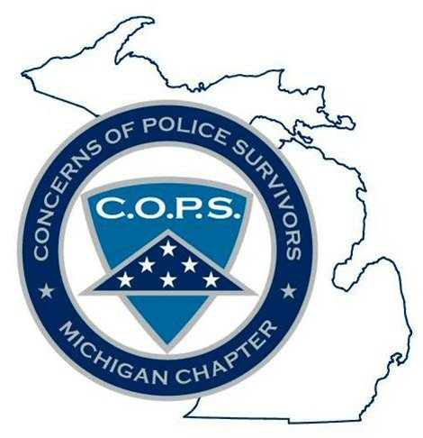

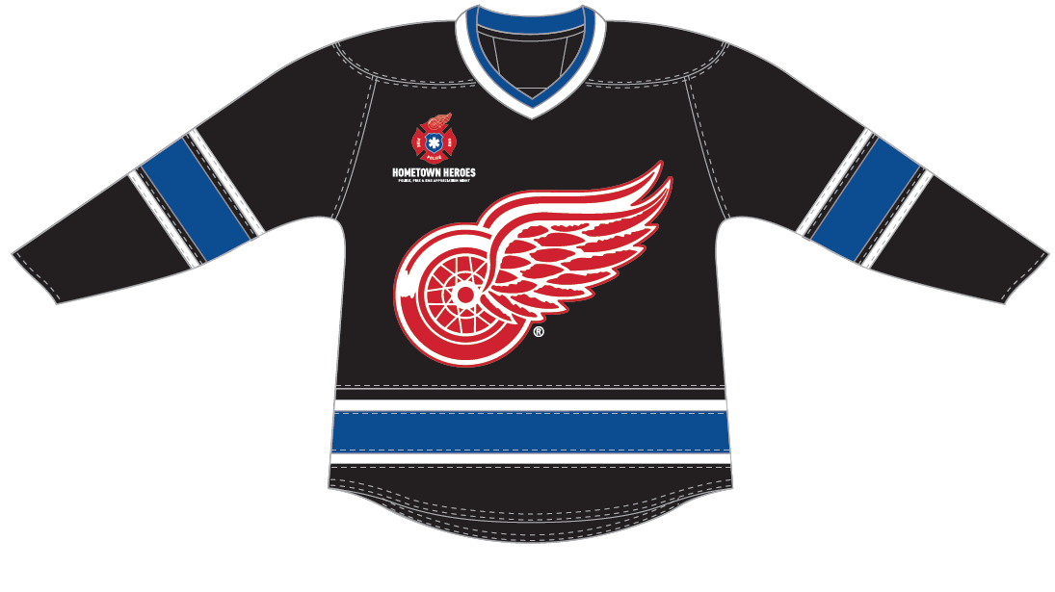

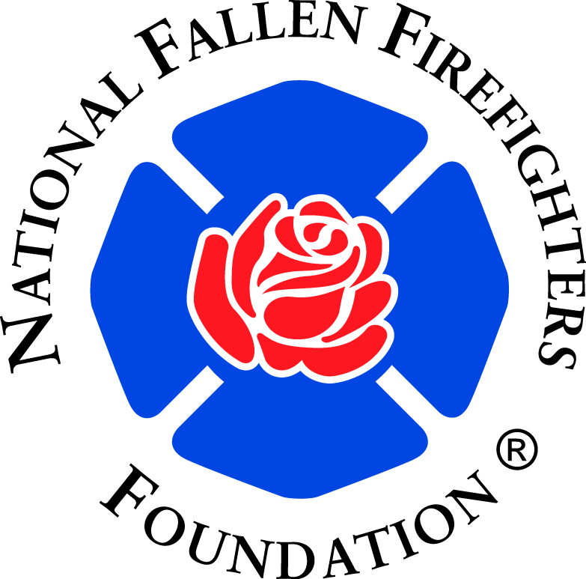

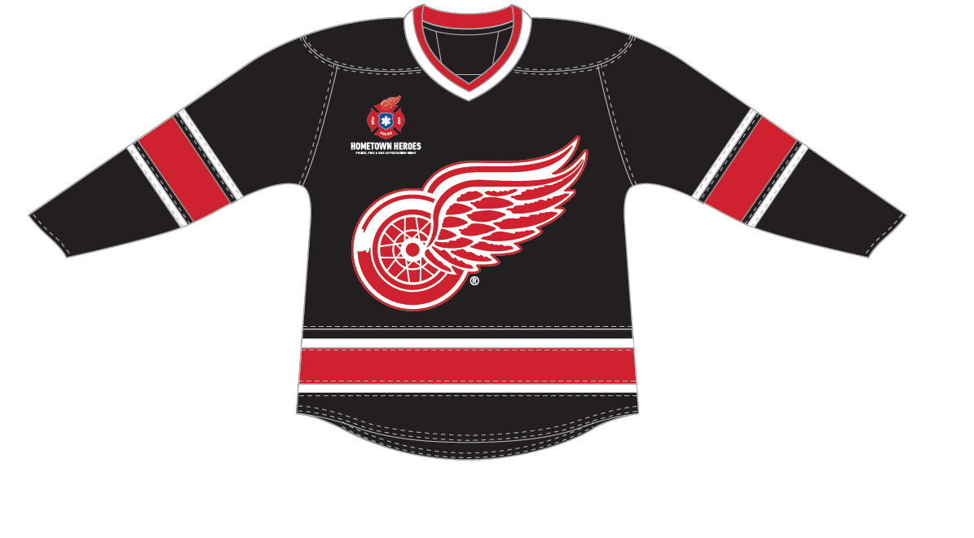

**Hometown Heroes Package Includes:**

